
Lebanese University
Faculty of Engineering III
Electrical and Electronic Department

______________________

ESP8266 remote smart car
  - Communication and Mini-Project
by
Sally Zaiter_6957
Dalia Ismail_6645
______________________

Spring 2025-2026

______________________

Supervisor: Dr. Rida Chall
Dr. Abdel Latif Samhat

Abstract
Robots have gained significant attention due to their wide range of applications.
Therefore, the Wi-Fi-Controlled Robot enhances remote operation capabilities by relying on the ESP8266’s wireless communication features. Unlike traditional wired systems, this project provides reliable control within the Wi-Fi network range. The web platform serves as an interface, allowing users to send real-time movement commands with minimal latency.
Movement commands are transmitted wirelessly to the ESP8266, which processes the commands and controls the robot's motors. The system can be integrated with additional sensors, such as ultrasonic sensors for obstacle detection or cameras for live video streaming, further expanding its functionality for advanced applications. With its cost effective approach and practical applications, this Wi-Fi-controlled robot demonstrates the growing role of wireless technology in robotics and automation/semi automation.
Furthermore, the Wi-Fi-Controlled Robot can be adapted for various real-world applications, such as home automation, warehouse management, and security patrolling. With the ability to operate remotely, it can be used in hazardous environments where human presence is risky, such as disaster zones or industrial sites with harmful substances. The project can also be enhanced with GPS for outdoor navigation or integrated with cloud platforms for remote data monitoring and control. Its versatility and scalability make it a valuable foundation for future advancements in autonomous and semi-autonomous robotic systems.

Keywords: Wi-Fi-Controlled Robot, ESP8266 module, wireless communication, real-time commands, wireless technology, operate remotely, autonomous and semi-autonomous robotic systems.

Table of Contents

Acknowledgment ii
Abstract iii
List of Figures vi
List of Tables vii
List of Abbreviations viii
Chapter 1 Introduction 1
1.1 Background Information 1
1.2 Problem Statement 1
1.3 Objective and Motivation 1
1.4 Thesis Outline 1
Chapter 2 Literature Review 2
2.1 Introduction 2
Chapter 3 System Design 3
3.1 Introduction 3
3.2 System Requirements 3
3.2.1 Use Case Diagram 3
3.3 System Architecture 3
3.4 Non-Functional Requirements 4
3.5 Conclusion 4
Chapter 4 Implementation and Results 5
4.1 Introduction 5
4.2 Implementation Tools 5
4.2.1 Software Tools 5
4.2.2 Hardware Tools 5
4.3 Implementation Steps 5
4.4 Results 5
4.5 Conclusion 5
Chapter 5 Conclusion 6
5.1 Conclusion 6
5.2 Future work 6
References 7
Appendices 8

List of Figures
fig1: microcontroller esp8266
fig2: NodeMCU ESP8266 pin diagram
fig 3: L298N motor driver diagram
fig4: DC motors

fig 5: Use Case Diagram
fig 6: Activity Diagram

fig 7: System Architecture

home page

Control Page (dashboard )

List of Tables

list of hardware components
wiring diagrams
tables of GPIO pins

Software Tools and used libraries

List of Abbreviations

IC | Integrated Circuit
IoT
NodeMCU Node MicroController Unit
GPIO | General purpose input output

: Introduction

Background Information
Recent advances in IoT technologies and wireless communication devices have significantly influenced the development of smart systems. Modern robotic systems are increasingly expected to have wireless control and communication with vehicles over local networks or the internet, providing greater mobility, flexibility, and ease of control.
Central to this system is the NodeMCU ESP8266 microcontroller, a popular choice among developers due to its versatility and ease of use, its compact size, low cost, and built-in WiFi functionality; which allows for straightforward connections to existing networks and devices. The project will involve not only the development of the hardware components—such as motors, a motor driver, sensors, and the NodeMCU; but also the creation of a robust software solution.
This software will facilitate seamless communication between the car and the user, to control and monitor the vehicle’s movements. The primary objective of this project is to develop a cohesive system capable of receiving commands wirelessly and executing corresponding actions with precision. The integration of various sensors can further enhance the vehicle's functionality. Moreover, we aim to design an intuitive user interface accessible, allowing users to control the car effortlessly from their smartphones or tablets.
By engaging with this project, we can gain valuable insights into programming, electronics, and the principles of wireless communication. Additionally, the versatility of the WiFi-controlled car design opens doors for further exploration in various domains, including robotics research, automation, and even smart home integration.

Problem Statement
Many existing robotic systems rely on wired connections or Bluetooth communication for remote control. Wired systems limit the robot's mobility due to the physical connection between the controller and the robot, while Bluetooth-based systems offer only a limited communication range and unstable connections in larger environments. In addition, wireless robotic platforms are relatively expensive or require complex hardware and software configurations.
Therefore, there is a need for a cost-effective, reliable, and easy-to-implement robotic system that enables real-time remote control over a Wi-Fi network. Such a system should provide greater communication range, flexible network connectivity, and the ability to integrate with smartphones. This project focuses on these challenges by developing a Wi-Fi-controlled robot using the ESP8266 NodeMCU microcontroller and a web-page control interface that can be further developed into a dedicated application.

Objective and Motivation
In order to design and implement a remote controlled robot car, we refer to the ESP8266 Wi-Fi nodeMCU as a microcontroller and an interface platform for user’s commands. The project aims to:
- develop an interface platform hosted by the ESP8266 that enables users to remotely control the robot car.
- establish reliable Wi-Fi communication between the web interface and the ESP8266 for real-time transmission of control commands.
- process the user’ commands through the ESP8266 to control the robot's movements and driving the DC motors via the L293N motor driver.
- integrate onboard sensors that monitor the vehicle's surroundings and transmit their status or notifications to the user through the created web interface.
- develop an integrated hardware and software system that demonstrates the practical application of IoT and wireless communication in remote vehicle control.
- provide a flexible platform that can be further enhanced with additional features, such as a dedicated mobile application, autonomous navigation in future work.
Our project was motivated by the need to explore the practical integration of embedded systems and wireless networking through a low-cost and user-friendly solution.
Developing a Wi-Fi-controlled robot car using the NodeMCU ESP8266 provides valuable hands-on experience in microcontroller programming, web-based communication, and hardware–software integration.

Thesis Outline
This report is organized into five chapters:
Chapter 1 – Introduction presenting background information, problem statement and objectives behind the development of the Wi-Fi controlled robot car.
Chapter 2 – Literature Review provides an overview of the concepts and technologies related to the project, including ESP8266 NodeMCU, the L293N motor driver, DC motors, sensors…
Chapter 3 – System Design describes the architecture of the proposed system. It includes the use case diagram, system architecture, and non-functional requirements.
Chapter 4 – Implementation and Results presents the hardware and software tools used, all the implementation steps, and the final results.
Chapter 5 – Conclusion summarizes the achievements of the project and possible future improvements.
At the end of the report, we include a list of references and appendices for supplementary information related to the project.

: Literature Review

Introduction
The purpose of this review is to provide the theoretical background researches necessary for understanding the design and implementation of the project.

ESP8266 Wi-Fi NodeMCU
What is NodeMCU? NodeMCU is an open-source LUA^{[1]} software and hardware development environment built around an inexpensive System-on-a-Chip (SoC) called the ESP8266. The ESP8266, designed and manufactured by Espressif Systems, contains the crucial elements of a computer: CPU, RAM, networking (WiFi), and even a modern operating system and SDK. That makes it an excellent choice for Internet of Things (IoT) projects of all kinds.
It is a low-cost, small, and powerful board, specifically designed for IoT applications. It is compatible with Arduino IDE and Python, making prototyping a lot faster. It can be programmed using the Arduino IDE to perform customized control, communication, and automation tasks.
[1] Lua is a powerful and fast programming language that is easy to learn and use and to embed into your application.

Nodemcu ESP8266 Specifications & Features:
- The onboard ESP8266 chip manufactured by Espressif Systems has an ESP8266EX core Wi-Fi SoC and a Tensilica L106 32-bit processor in the same chip.
- Node MCU ESP8266 has 2.4GHz 802.11b/g/n Wi-fi with on-board antenna, which supports WPA/WPA2.
- It has 17 GPIO, 11 are usable ( 6 are used for communication with the onboard flash memory chip), and some of them support PWM. This GPIO can be used to interface the ESP8266 NodeMCU with the external environment through sensors and actuators.
- It also has UART, SDIO, SPI, I2C, I2S, and an IR remote control peripheral interface.
- It operates on 2.5- 3.6V and averages 80mA current.
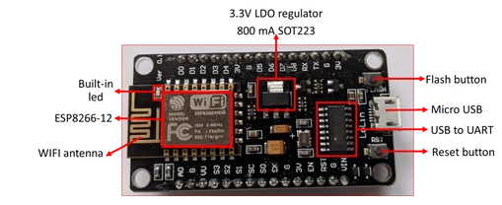
fig1: microcontroller esp8266

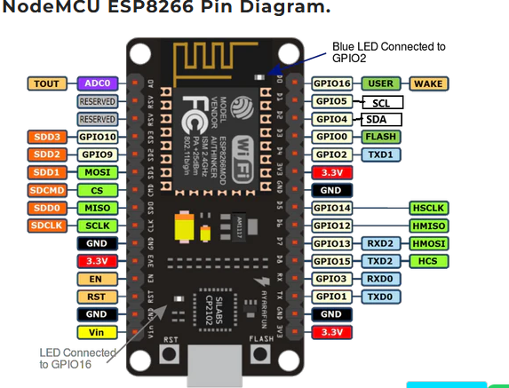
fig2: NodeMCU ESP8266 pin diagram

How Wi-Fi works on it?
The ESP8266 includes a built-in 2.4 GHz Wi-Fi transceiver and TCP/IP protocol stack, which enables it to connect to wireless networks or operate as an access point. It supports different operating modes such as Station (STA): connected to an existing router or Access Point (AP): creates its own Wi-Fi network that other devices can connect to, or a combination of both. Communication with the module is typically done using HTTP requests or socket-based protocols, enabling real-time data exchange between the web interface and the microcontroller.
Why it is used in our project?
Our choice was NodeMCU ESP8266 because it provides an integrated solution for wireless communication and control in a single low-cost device, already includes built-in connectivity. In this project, it serves as the main control unit that receives commands from the web-based interface and translates them into signals for the motor driver, enabling real-time control of the robot car.
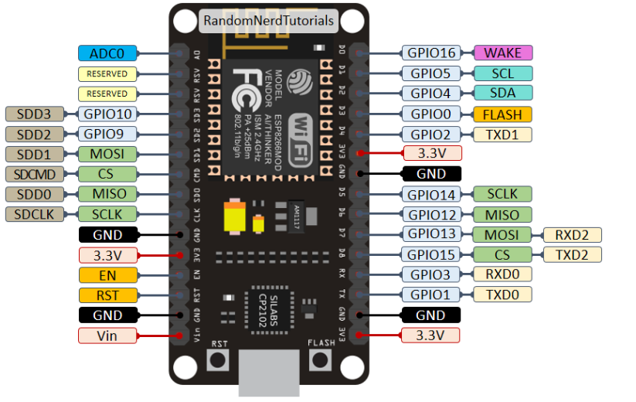

L298N motor driver
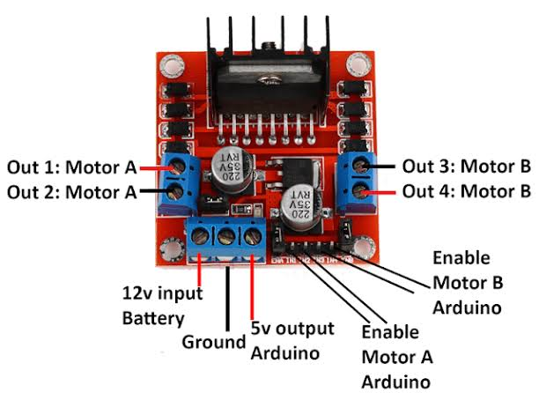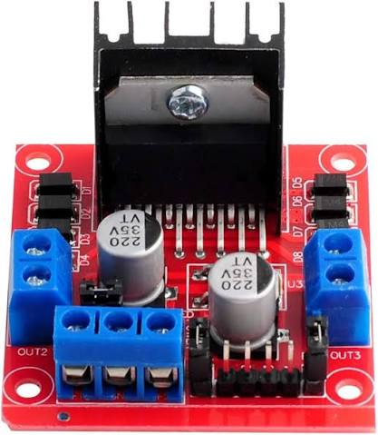
fig 3: L298N motor driver diagram
what is the L298N? The L298N is a dual H-bridge motor driver integrated circuit designed to interface low-power control circuits with high-current loads such as DC motors. It acts as an intermediary between the microcontroller and the motors by receiving low-current control signals and supplying sufficient current from an external power source to drive the motors safely.
why to use it? The GPIO pins of the NodeMCU ESP8266 operate at logic levels and are designed to source or sink only a limited amount of current. Since DC motors require a significantly higher current than the ESP8266 can safely provide, connecting a motor directly to the microcontroller can damage its output pins or prevent the motor from operating correctly. Therefore, a motor driver such as the L298N is required to isolate the microcontroller from the motor load while providing the necessary driving current.
The L298N controls the direction of a DC motor using an H-bridge configuration. By changing the logic levels applied to its input pins, the current flowing through the motor can be reversed, allowing the motor to rotate in either the clockwise or counterclockwise direction. In addition, the enable pins can be used to activate or deactivate the motors and can also support speed control through Pulse Width Modulation (PWM).
In this project, the L298N motor driver is used to interface the NodeMCU ESP8266 with the DC motors of the smart car. It receives movement commands processed by the ESP8266 and converts them into the appropriate motor control signals, enabling the vehicle to move forward, backward, turn left, turn right, and stop. The motor driver ensures reliable motor operation while protecting the microcontroller from excessive current demands.

DC motors
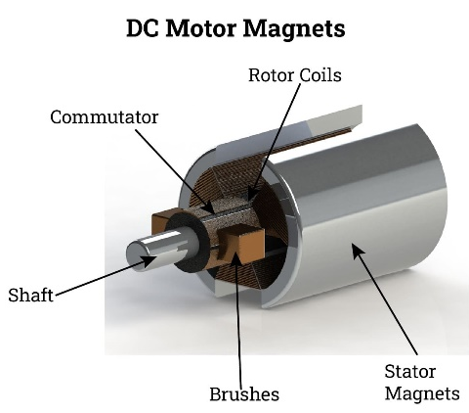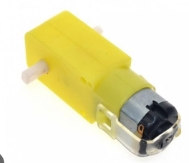
fig4: DC motors
A Direct Current (DC) motor is an electromechanical device that converts electrical energy into mechanical energy through the interaction between magnetic fields and current-carrying conductors. DC motors are widely used in mobile robots, electric vehicles, industrial automation, and consumer electronics.

The operating principle of a DC motor is based on the electromagnetic force produced when an electric current flows through a conductor placed within a magnetic field. This interaction generates a torque that causes the motor shaft to rotate. By controlling the polarity of the applied voltage, the direction of rotation can be reversed, while varying the supplied voltage or using Pulse Width Modulation (PWM) allows the motor speed to be adjusted.

In robotic applications, DC motors provide the mechanical power required to move the vehicle. Their rotational motion is transmitted to the wheels, enabling forward, backward, and turning movements according to the control signals received from the motor driver. Their compact size, low cost, and compatibility with motor driver circuits make them a suitable choice for Wi-Fi-controlled robotic vehicles.

Wi-Fi communication and Web-Based Control Interface
In Wi-Fi-controlled applications, data are exchanged over a Wireless Local Area Network (WLAN) based on the IEEE 802.11 standards. The NodeMCU ESP8266 integrates a built-in Wi-Fi transceiver and TCP/IP protocol stack, enabling it to communicate directly with network devices without additional communication hardware. In this project, the Access Point (AP) mode is used, which means the ESP8266 creates its own wireless network for nearby devices.
The ESP8266 hosts a lightweight web server that stores the HTML control interface, which is accessed through the module's assigned IP address using any standard web browser. When a user presses a control button on the web page, the browser sends an HTTP request to the ESP8266 via the Wi-Fi connection. The ESP8266 continuously monitors incoming requests, interprets the corresponding commands, and generates the appropriate control signals for the L298N motor driver, which in turn controls the movement of the robot car. This communication mechanism provides responsive and reliable real-time remote control while maintaining a simple, low-cost, and efficient system architecture.
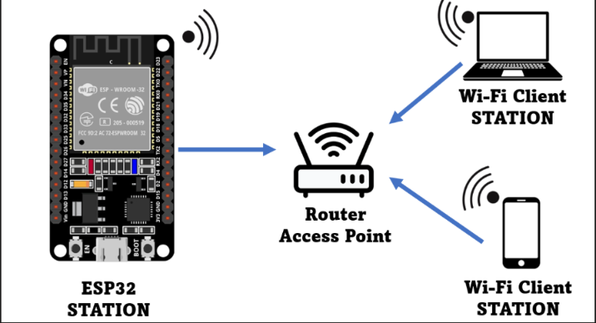

Sensors and Arduino

arduino uno:
The Arduino Uno is an open-source microcontroller development board based on the ATmega328P microcontroller. It provides digital and analog input/output pins that enable communication with sensors, actuators, and other electronic devices. The board is widely used in embedded systems and prototyping due to its simplicity, low cost, and compatibility with the Arduino IDE

leds and resistors:
A Light Emitting Diode (LED) is a semiconductor device that emits light when an electric current passes through it. LEDs are commonly used as visual indicators. In this project, LEDs are used to indicate the operating status of the system. A resistor is a passive electronic component that limits or controls the flow of electric current in a circuit. It is commonly used to protect electronic components, regulate voltage levels, and control current through devices such as LEDs.

motion sensor
Passive Infrared (PIR) motion sensor detects movement by sensing changes in infrared radiation emitted by objects such as the human body. When motion is detected within its sensing range, the sensor generates a digital output signal that can be processed by a microcontroller. In this project, the motion sensor is used to detect nearby movement and activate the corresponding response.

buzzer
An electroacoustic device that converts electrical energy into sound. In this project, the buzzer is activated to alert the user when specific sensor conditions are detected.

photoresistor
photoresistor, also known as a Light Dependent Resistor (LDR), is a light-sensitive component whose resistance varies according to the intensity of incident light. As the light intensity increases, its resistance decreases, allowing it to detect changes in ambient lighting conditions. we used the photoresistor to monitor the surrounding light level.

servo motor
servo motor is a rotary actuator designed to provide precise control of angular position. It consists of a DC motor, a gear mechanism, a position sensor, and an internal control circuit that continuously adjusts the shaft to the desired angle based on the input control signal.

: System Design

Introduction
This chapter presents the design and architecture of the proposed Smart Car Controlled by ESP8266 to moving, detect obstacles and motions. In addition to some smart controls like open rear door using the servo motor, leds turns ON in darkness.

System Requirements
Detailed description of the system's functionalities from a user's perspective. This includes what actions the system should perform, such as user interactions, data processing, and system responses.

Use Case Diagram

Drive motors
ESP8266
Car controller system
Open the rear door
Association
include
Read distance with message (very close)
Read motion sensor with buzzer
Activate
servo motor
Enable and Detect motion for security
Automatic light in darkness
User
Detect obstacles

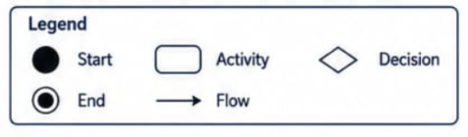
3.2.2 Activity Diagram

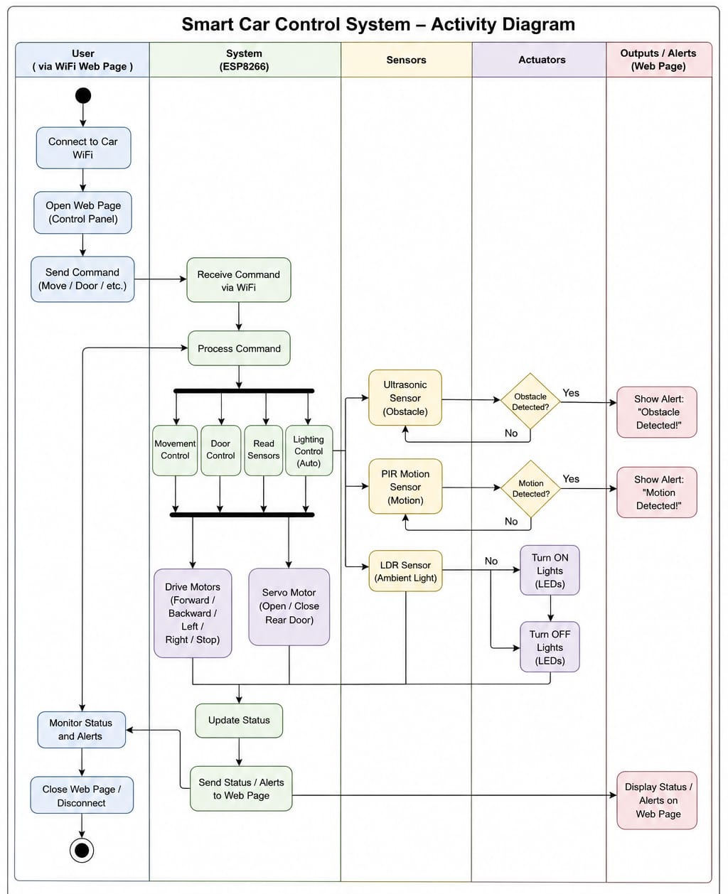
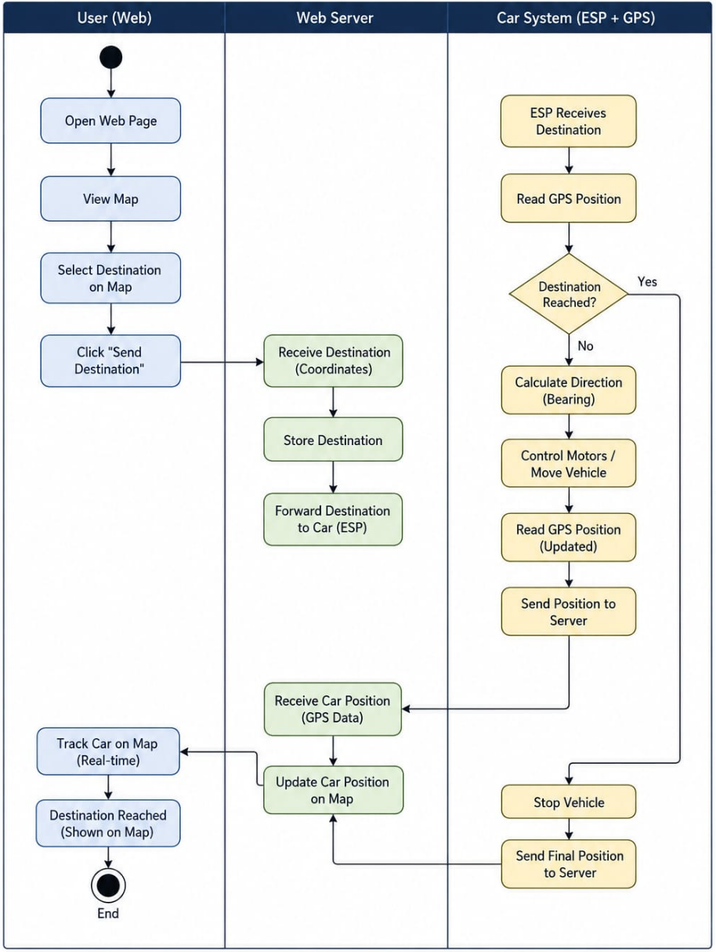
3.2.2 Activity Diagram

System Architecture
High-level block diagram illustrating the major components and their interactions.
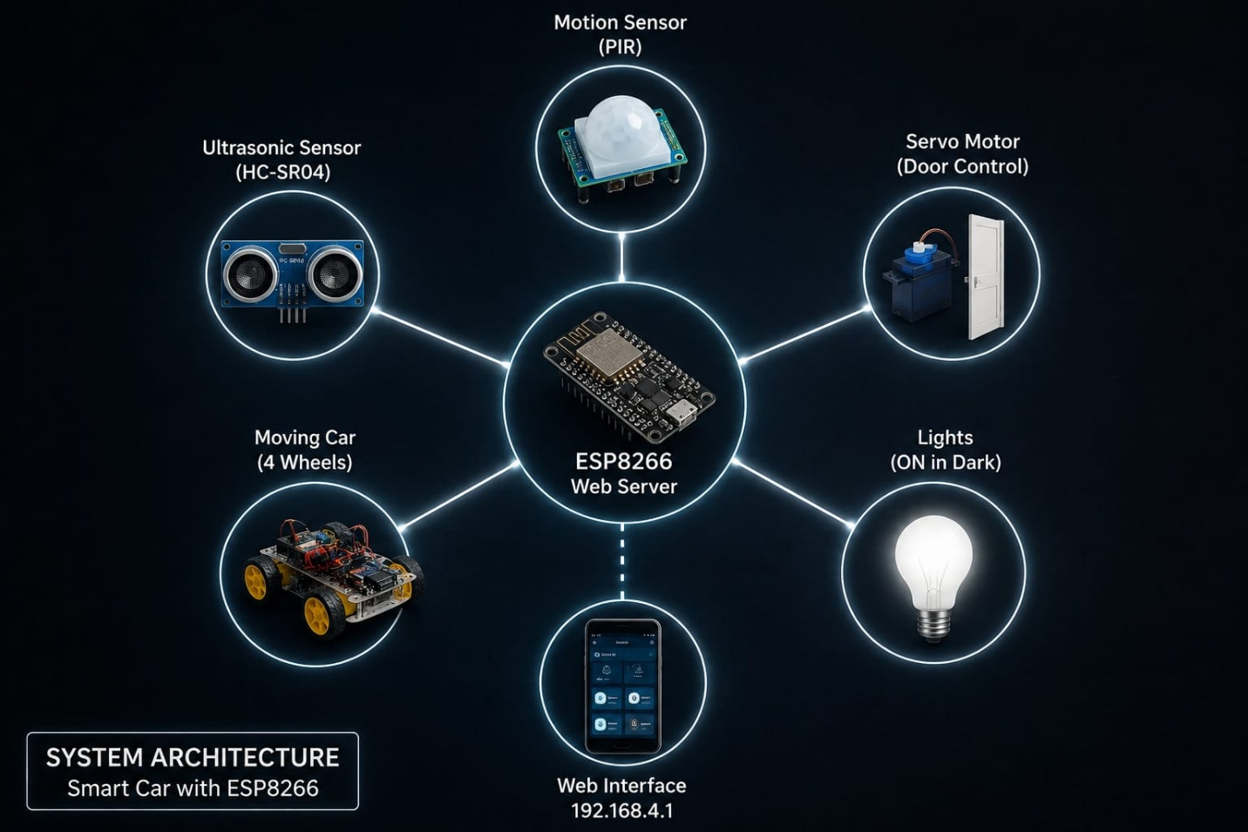

Figure 7: System Architecture

User gets access to password in order to connect to wifi after Open page at address 192.168.4.1(Web Server) HTTP Request Get html page (UI)Control car …

Non-Functional Requirements
- Performance:
The system shall respond to user commands from the web page within < 1 second.
Sensor readings (ultrasonic, motion) shall update at least every 500 ms – 1 s.

- Reliability: The system shall maintain stable connection with ESP8266 wifi with at least 90% uptime during operation.

- Security: The web interface should not be publicly exposed without WiFi access (Password).

- Usability: The web page shall be simple and usable from a mobile phone without zooming. Controls (buttons for forward, back, servo, etc.) shall be clearly labeled. Alerts (motion, obstacle) shall be easy to understand (e.g., “Obstacle detected!”)..

- Availability: The system shall be available for user control at least 95% of the time during normal operation. The ESP8266 web interface shall remain accessible as long as the device is powered and connected to Wi-Fi.

- Accuracy: The system shall provide accurate sensor readings from the ultrasonic and motion sensors, with an acceptable error margin (e.g., ultrasonic distance error ≤ ±2–3 cm under normal conditions). Obstacle detection shall correctly identify objects in front of the car with a high detection success rate (≥ 90% in normal lighting and range conditions).

Conclusion

This chapter presented the design of the proposed Smart Car Controlled by ESP8266. The system requirements, use case diagram, activity diagram, system architecture, and non-functional requirements were described. These design specifications provide a clear framework for the implementation phase and ensure that the system meets its tracking and navigation objectives.

: Implementation and Results

Introduction
In this chapter, we present the implementation steps. Describing the hardware and software tools used to develop the system. It includes details of software coding, hardware assembly, testing procedures and results. The chapter also explains the implementation process, system integration, testing procedures, and the results obtained to evaluate the performance of the proposed solution.

Implementation Tools
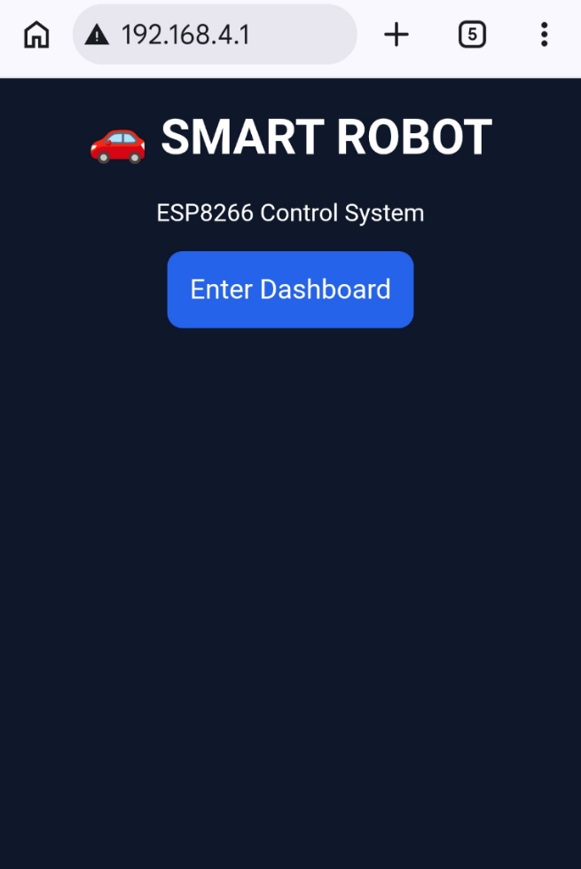
- home page :

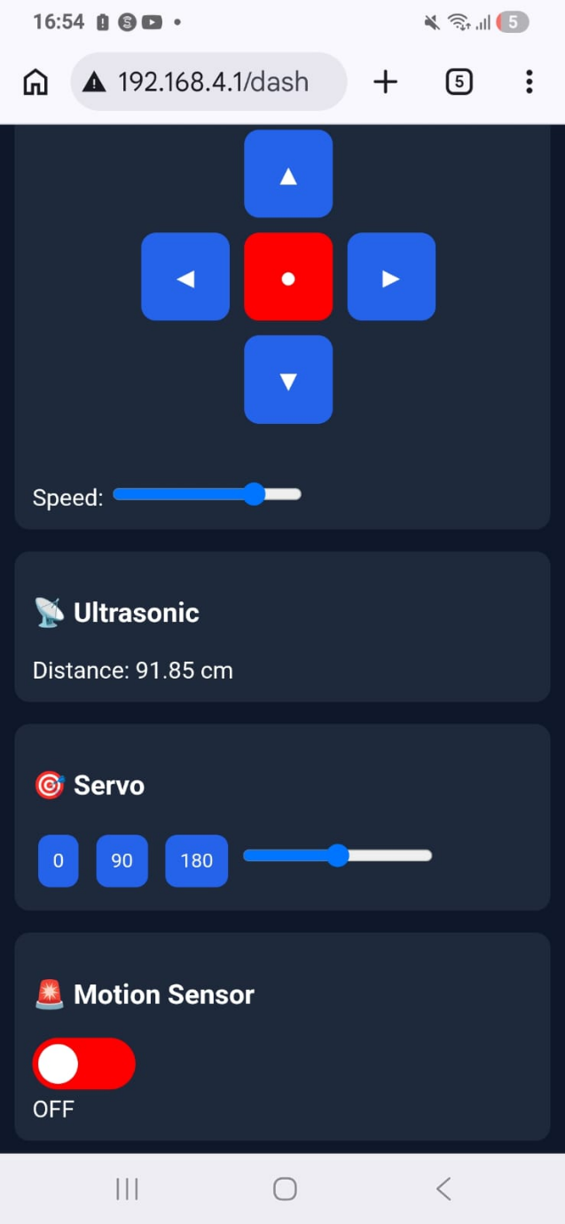
- Control Page(dashboard):

table : list of hardware components
component |  | quantity | purpose
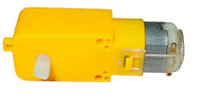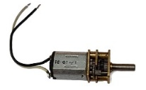 | 5V DC Gear motors | 4 | Drive the smart car
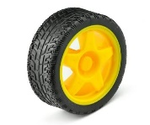 | rubber wheel | 4 | Vehicle movement
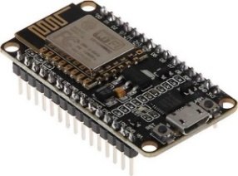 | NodeMCU ESP8266 | 1 | Main microcontroller and Wi-Fi communication
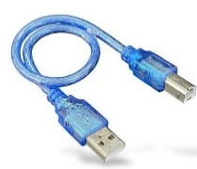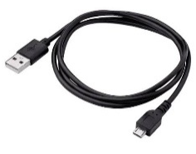 | Usb
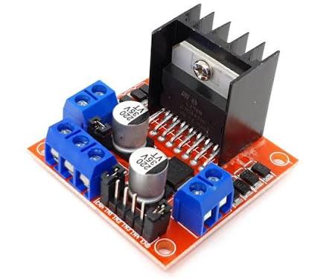 | L298N Motor Driver | 1 | Controls the DC motors
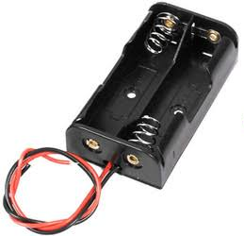 | Lithium battery 3.7 V  With battery holder | 2 | Main power supply  Connects battery to the circuit
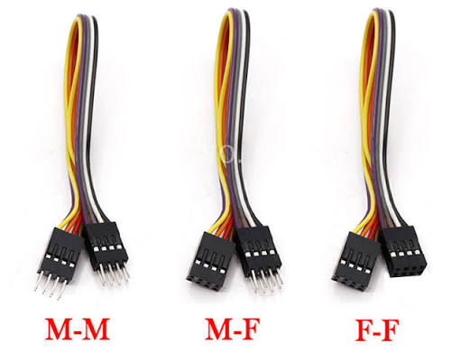 | Jumper wires | many | Electrical connections
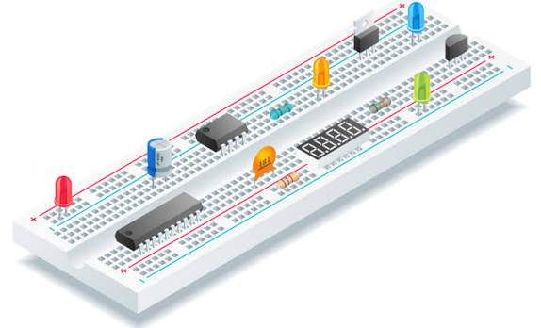 | Breadboard | 2 | Temporary prototyping and circuit connections
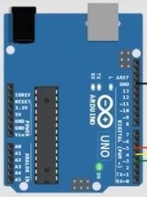 | Arduino uno | 1 | microcontroller
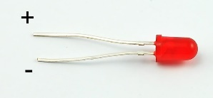 | Leds |  | Indicate system status.
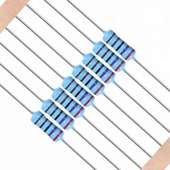 | Resitors |  | Limit electrical current.
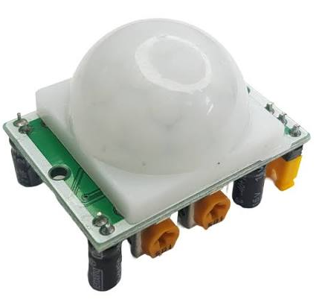 | Motion sensor | 1 | Detects motion.
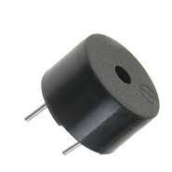 | Buzzer | 1 | Provides audio alerts.
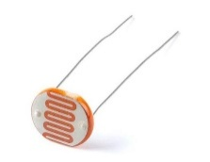 | Photoresitor | 1 | Detects light intensity.
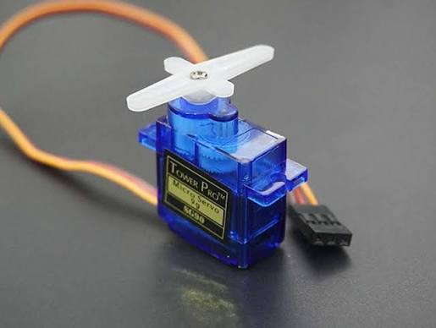 | Servo motor | 1 | Rotates the sensor module.

hardware connections
all the wiring diagrams are done by us on https://www.cirkitdesigner.com/esp32-simulator
for every component, we will show:
- wiring diagram
- table of GPIO pins

note: for a common pin where we should have multiple wires, we will use the breadboard.

Motor driver L298N and esp:
L298N pins | Esp8266 pins
IN1 | D1
IN2 | D2
IN3 | D3
IN4 | D4
GND | GND and (–) battery  Common gnd
OUT1, OUT2 | one side of the car
OUT3, OUT4 | other side of the car
+12V | + battery
+5V | Vin
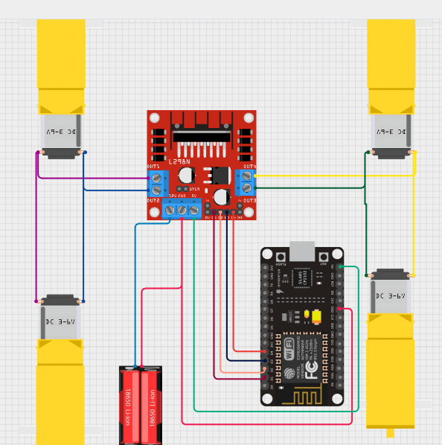

Ulrasonic sensor:
Ultrasonic sensor pins | Esp8266 pins
Vcc | Vin
TRIG | D7
ECHO | D8
GND | GND
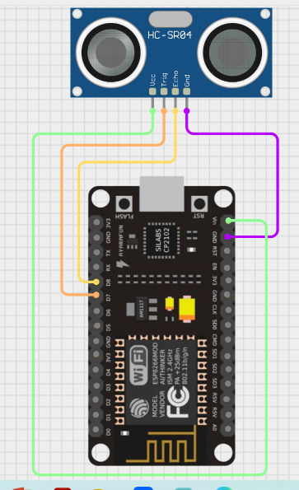

servo motor:
Servo motor pins | Esp8266 pins
out | D0
GND | GND
Vcc | Vin
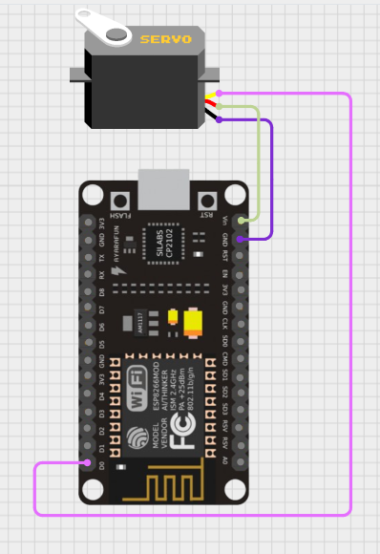

motion sensor:
motion sensor pins | Esp8266 pins
Vcc | Vin
out | D5
GND | GND
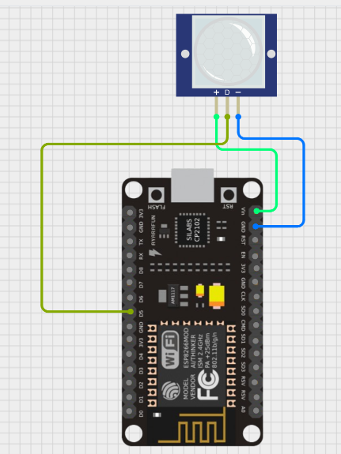

buzzer:
Buzzer pins | Esp8266 pins
- | Gnd
+ | D6
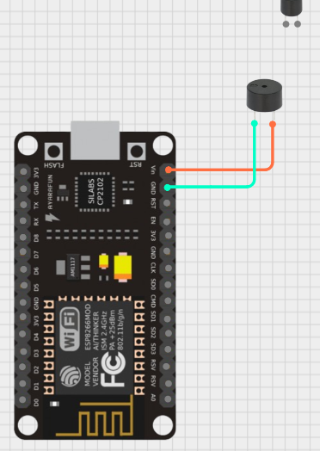

Arduino uno , photoresistor , led
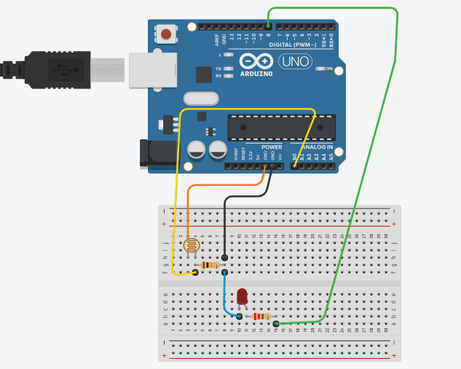
Photoresistor pins
One side | 5V of Arduino pins
Other side | Resistor 10 kohm
Resistor 10 kohm
One side | Common with photoelectric  And to pin A0 of Arduino uno
Other side | GND
Led pins
cathode | Resistor 220kohm | D8 of Arduino uno
anode | gnd

4.3.1 Software Tools
Arduino IDE | Write, compile and upload the program to the nodemcu esp8266
HTML | To create login page and dashboard interface
CSS | Design and style the web pages
JavaScript | Add interactivity and handle user actions on web interface

4.3.2 Libraries used
library | purpose
<ESP8266WiFi.h> | Enable esp8266 to connect to a wifi network
<ESP8266WebServer.h> | To create web server on nodemcu to host control webpage and process user requests
<Servo.h> | To control the motor’s position by generating PWM signals

Implementation Steps
step 1: hardware assembly
wire every component to the microcontroller, and uploading the given code to test it.
- Connect the Dc motors to the L293N motor driver
Connect the NodeMCU ESP8266 to the L293N motor driver.
refer the wiring diagram and the table of GPIO pins, the given code:
// PINS configurations : MOTOR define pins
#define IN1 D1
#define IN2 D2
#define IN3 D3
#define IN4 D4

// lal Motor control fct prototype
void forward();
void backward();
void left();
void right();
void stopMotor();

void setup() {
// MOTOR PINS to tell the esp how each pin will behave ,
//output: esp sends voltage ! input : esp reads voltage
pinMode(IN1,OUTPUT); pinMode(IN1, OUTPUT);
pinMode(IN2, OUTPUT);
pinMode(IN3, OUTPUT);
pinMode(IN4, OUTPUT);
}

// MOTOR FUNCTIONS :1 for high and 0 for low
void forward() { //in this way the motors move forward
digitalWrite(IN1, 1);
digitalWrite(IN2, 0);
digitalWrite(IN3, 1);
digitalWrite(IN4, 0);
}

void backward() {
digitalWrite(IN1, 0);
digitalWrite(IN2, 1);
digitalWrite(IN3, 0);
digitalWrite(IN4, 1);
}

void left() {
digitalWrite(IN1, 0);
digitalWrite(IN2, 1);
digitalWrite(IN3, 1);
digitalWrite(IN4, 0);
}

void right() {
digitalWrite(IN1, 1);
digitalWrite(IN2, 0);
digitalWrite(IN3, 0);
digitalWrite(IN4, 1);
}

void stopMotor() {
digitalWrite(IN1, 0);
digitalWrite(IN2, 0);
digitalWrite(IN3, 0);
digitalWrite(IN4, 0);
}

//define a function to know each button function void handleMove() {
String d = server.arg("dir");

if (d == "F") forward();
else if (d == "B") backward();
else if (d == "L") left();
else if (d == "R") right();
else stopMotor();

server.send(200, "text/plain", "OK");
}

//web page design and fctionalityy
void dashboard() {
server.send(200, "text/html", R"rawliteral(
<!DOCTYPE html>
<html>
<head>
<meta charset="UTF-8">
<meta name="viewport" content="width=device-width, initial-scale=1">
body{margin:0;font-family:Arial;background:#0f172a;color:white;}
.header{text-align:center;padding:12px;background:#111827;}
.container{
display:flex;
flex-direction:column;
gap:15px;
padding:10px;
}

.card{
width:100%;
background:#1e293b;
padding:12px;
border-radius:10px;
box-sizing:border-box;
}
button{padding:10px;margin:4px;border:none;border-radius:8px;background:#2563eb;color:white;}
.alert{display:none;background:red;padding:10px;border-radius:8px;margin-top:10px;}
.pad{
display:grid;
grid-template-columns: 60px 60px 60px;
grid-template-rows: 60px 60px 60px;
justify-content:center;
align-items:center;
gap:10px;
margin-top:10px;
}

.pad button{
width:60px;
height:60px;
font-size:20px;
border-radius:10px;
}

/* for design buttons */

.up{grid-column:2;grid-row:1;}
.left{grid-column:1;grid-row:2;}
.stop{grid-column:2;grid-row:2;background:red;}
.right{grid-column:3;grid-row:2;}
.down{grid-column:2;grid-row:3;}
</style>
</head>

<body>
<div class="header">SMART DASHBOARD</div>
<div class="container">
<div class="card">
<h3>🚗 Control</h3>
<div class="pad">
<button class="up" onclick="cmd('F')">▲</button>
<button class="left" onclick="cmd('L')">◀️</button>
<button class="stop" onclick="cmd('S')">●</button>
<button class="right" onclick="cmd('R')">▶️</button>
<button class="down" onclick="cmd('B')">▼</button>
</div>

<script>
function cmd(d){fetch('/move?dir='+d);}
</script>

</body>
</html>
)rawliteral");
}
- Connect the ultrasonic sensor to the esp8266 nodemcu
according to the wiring diagram and the table of GPIO pins, the given code:
// ULTRASONIC pins
#define TRIG D7 // triger the motion
#define ECHO D8 // send back the motion
float distance = 0; // initial distance ultrasonic sensor
void getDistance();
void alertBox();
void readDistance();

void setup(){
// configure the ULTRASONIC sensor
pinMode(TRIG, OUTPUT); // trig sends short pulse
pinMode(ECHO, INPUT); // echo receives the reflected pulse

void readDistance() {
digitalWrite(TRIG, LOW);
delayMicroseconds(2);
digitalWrite(TRIG, HIGH);
delayMicroseconds(10);
digitalWrite(TRIG, LOW);

long duration = pulseIn(ECHO, HIGH, 30000);
distance = duration * 0.034 / 2;
}
//function to get it in our page
void getDistance() {
server.send(200, "text/plain", String(distance));
}
// function to get message obatcle detected when <7
void alertBox() {
if (distance > 0 && distance < 7)
server.send(200, "text/plain", "1");
else
server.send(200, "text/plain", "0");
}

void loop(){}

- servo motor to esp8266
#include <Servo.h> // library dedicated for the servo motor actionss
Servo myservo; //creates object for the future commands

int speedVal = 800; //for the speed of the motor
void handleSpeed();
void handleServo();

void setup(){
// SERVO define pin and initial state
myservo.attach(D0);
myservo.write(90);
stopMotor();

}

void handleSpeed() {
speedVal = server.arg("val").toInt();
// reads slider value and stores in the variable
server.send(200, "text/plain", "OK");
}

void handleServo() {
//to read the angle from the user commands and rotates the servo accordingly
myservo.write(server.arg("angle").toInt());
server.send(200, "text/plain", "OK");
}

- motion sensor ,buzzer to the esp8266
//system of motion sensor with buzzer define pins
#define BUZZER D6
void handleToggleMotion();
void getMotionStatus();

void setup() {
// conf sensor motion
pinMode(PIR,INPUT); //pir sensor sends high or low to the esp
pinMode(BUZZER,OUTPUT); //esp controls when buzzer turns on or off
digitalWrite(BUZZER,LOW); //turn off the buzzer initially
}

void handleToggleMotion() {
motionEnabled = !motionEnabled;
server.send(200, "text/plain", motionEnabled ? "ON" : "OFF");
}

void getMotionStatus() {
if (!motionEnabled) {
digitalWrite(BUZZER, LOW);
server.send(200, "text/plain", "OFF");
return;
} //when motion sensor enable

int pir = digitalRead(PIR);

if (pir == HIGH) {
digitalWrite(BUZZER, HIGH);
server.send(200, "text/plain", "MOTION!");
} else {
digitalWrite(BUZZER, LOW);
server.send(200, "text/plain", "NO MOTION");
}
} // if motion detected buzzer is high

void loop(){}

- LED, and photoresistor to the Arduino uno
const int ldrPin = A0;
const int ledPin = 8;

void setup() {
pinMode(ledPin, OUTPUT);
}

void loop() {
int light = analogRead(ldrPin);

if (light < 500) { // Dark
digitalWrite(ledPin, HIGH);
} else { // Bright
digitalWrite(ledPin, LOW);
}

delay(100);
}
- check and verify all power and GPIO connections.
step 2: software development
- Developed the control program using Arduino IDE.
- Included the required libraries (ESP8266WiFi.h, ESP8266WebServer.h, Servo.h).
//include the libraries to usee
#include <ESP8266WiFi.h>
#include <ESP8266WebServer.h>
#include <Servo.h>

step 3 : web interface and wifi configuration
Designed the HTML login page.
Developed the dashboard for controlling the robot.
Added buttons to send movement commands (Forward, Backward, Left, Right, Stop).
// check the html , css code in the result part
Configured the ESP8266 to connect to the Wi-Fi network, IP address which host the control webpage: The ESP8266 was configured to connect to the local Wi-Fi network using the network credentials. After establishing the connection, the assigned IP address was verified and set to a fixed address by assigning ‘.1’ to ensure stable and reliable access to the web-based control interface. The ESP8266 then hosted the web server, allowing users to access the login page and dashboard through a web browser.

Step 4 : During development, voice control directly through the web page was considered, but due to privacy and browser permission limitations, a separate voice control application was developed using MIT App Inventor. This application uses block-based programming to recognize voice commands and send the required instructions to the system.

step 4 : system
Linked the web interface with the ESP8266.
Tested communication between the webpage and the robot.
Verified that each command correctly controlled the robot.

step 5 : Testing and Validation
Tested robot movement in all directions.
Tested obstacle detection using the ultrasonic sensor.
Verified the servo motor scanning function.
Tested the buzzer, LED, and photoresistor responses.
Confirmed stable operation of the complete system.

Results
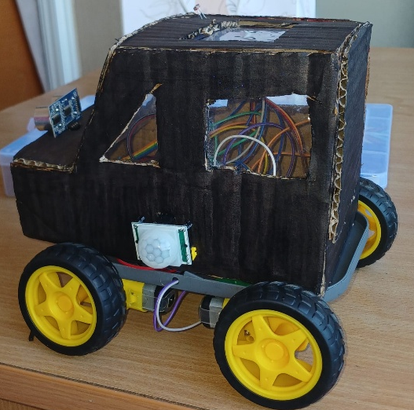
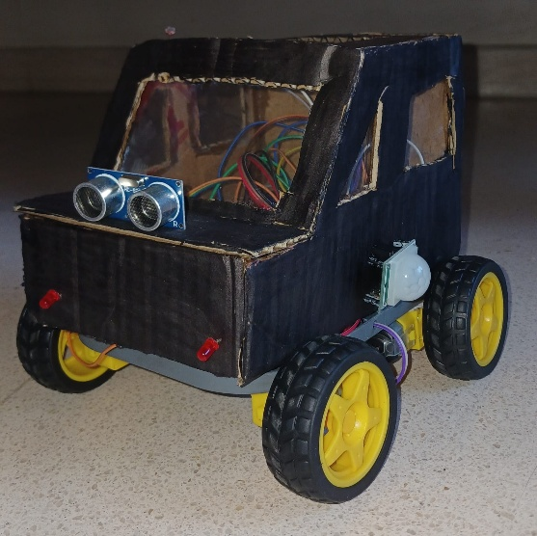

final code:
click here:
https://github.com/sally555-student/full-code-arduino-car
User -> HTML Web Interface (HTTP request) -> Wi-Fi Network -> ESP8266 -> L298N -> DC Motors

Conclusion
we successfully integrated the hardware and software components into a functional Wi-Fi controlled smart car. After completing the assembly, programming, and system configuration, all modules operated together as intended.

: Conclusion

Conclusion
This project successfully designed and implemented a Wi-Fi controlled robot based on the NodeMCU ESP8266 platform. The developed system integrates hardware components, such as motor driver, DC motors, ultrasonic sensor, servo motor, buzzer, and photoresistor, with a web-based interface that enables remote control through a Wi-Fi connection.
The smart car was able to execute movement commands, detect obstacles, and provide reliable communication between the user and the embedded system. Overall, our project achieved its objectives and demonstrated the effectiveness of combining embedded systems, web technologies, and wireless communication in a practical robotic application.

Future work
Several improvements can be considered for future development of the project.
A mobile application can be developed to replace the web interface and provide a more user-friendly experience.
A camera module may be added for real-time video streaming and remote monitoring.
Additional sensors like GPS or infrared sensors, can enhance the robot's navigation capabilities.
The obstacle avoidance algorithm can also be improved using artificial intelligence techniques, allowing the robot to operate more autonomously in dynamic environments.
Furthermore, integrating cloud services for data storage and remote monitoring would increase the system's functionality and scalability.
References
https://www.nabto.com/esp8266-for-iot-complete-guide/
https://www.electronicwings.com/nodemcu/introduction-to-nodemcu
https://robocraze.com/blogs/post/what-is-nodemcu-esp8266?srsltid=AfmBOoofdRjUV97U07oQR9YvYagEUZjk4M81cBM_Gq75JEN-cthi8G2N
https://www.ic-components.com/blog/l293d-vs-l298n-motor-driversfeatures,applications,and-practical-insights.jsp
https://www.sciencedirect.com/topics/engineering/dc-motor
https://www.researchgate.net/publication/378222234_Exploring_the_Potential_of_ESP8266_A_Wireless_Control_Experiment
https://app.cirkitdesigner.com/project/caa1acad-6309-4d42-b8dc-1a22d6c3f719

Appendices

